Carbon Dioxide – C0₂

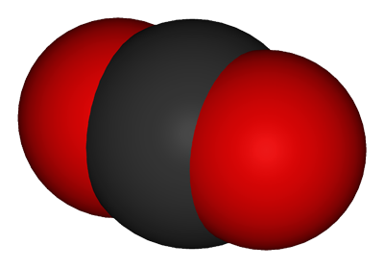

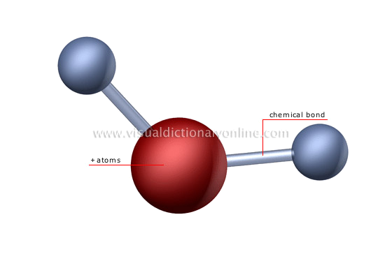

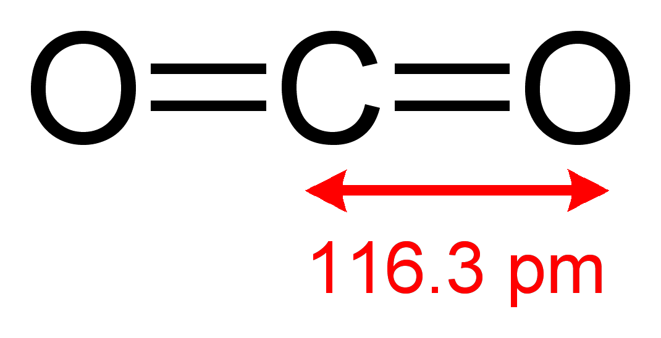

Water – H₂0

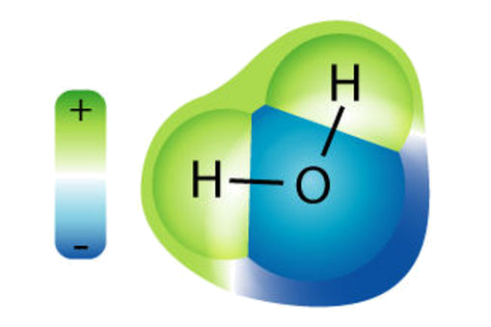

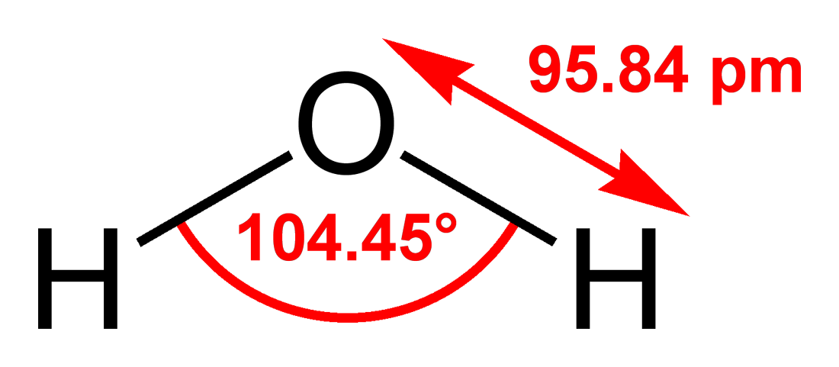

Oxygen – 0₂

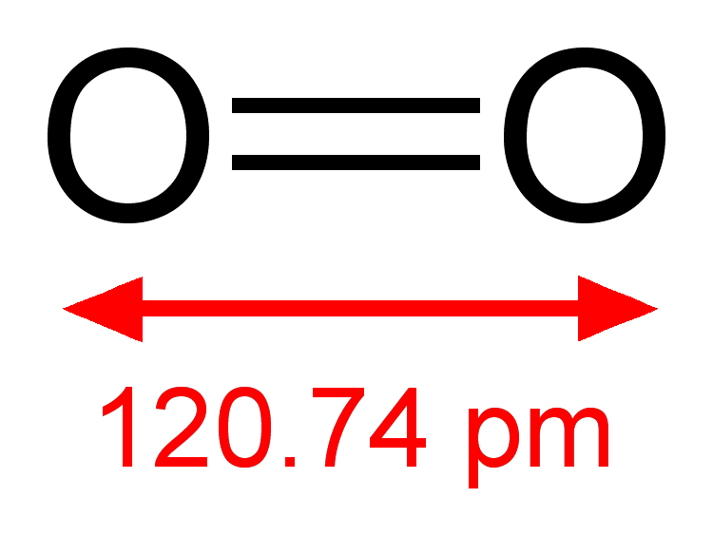

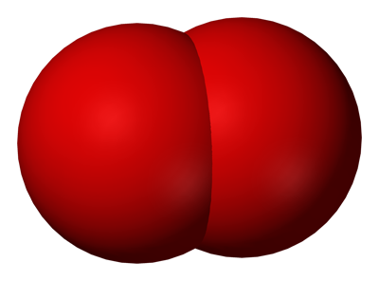

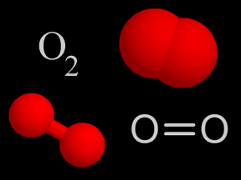
Ethyl Alcohol – C₂H₅OH

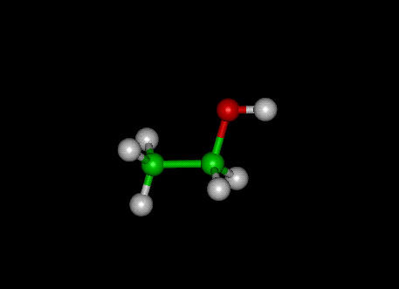

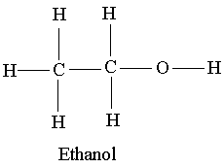

Ethyl Alcohol = Ethanol

Glucose – C₆H₁₂O₆

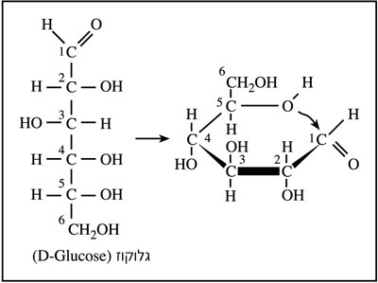

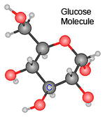

Photosynthesis

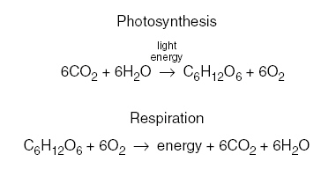

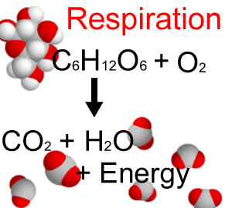

C
Anaerobic Respiration

C₆H₁₂O₆→2C₂H₅OH + 2C0₂ + 2ATP

Glucose: C₆H₁₂O₆

2 Ethyl Alcohol: 2C₂H₅OH

Carbon Dioxide: 2C0₂

Adenosine Triphosphate: 2ATP

  

